
Lab Program Number: 29 Date: 15th March,2026
Title: Users, Groups, Permission

- Create a user named “student”:
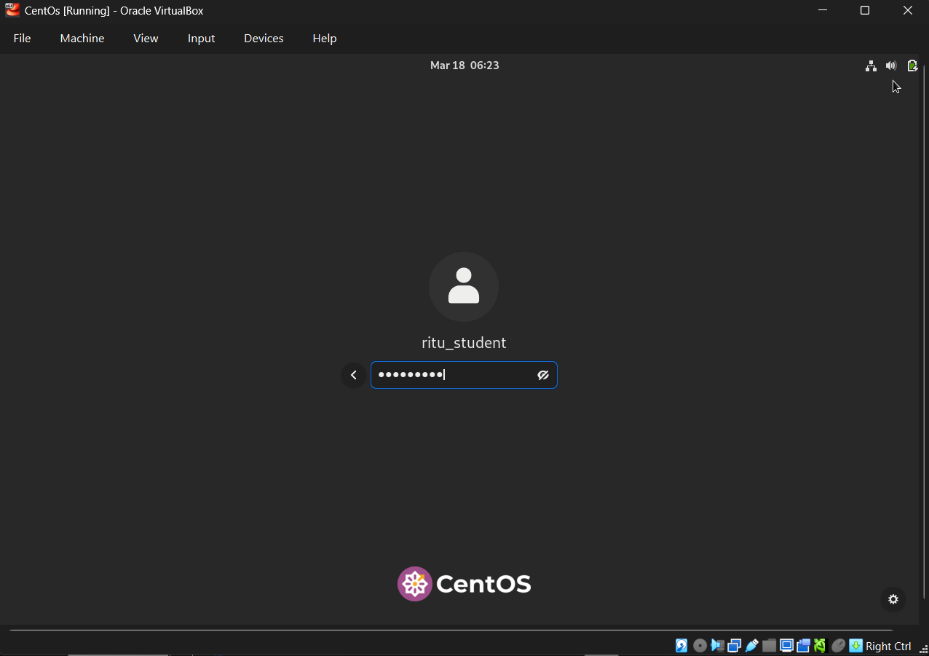

- Login from “student” user then create files and folders according to following tree structure [d1 = directory & f = file:
Commands:
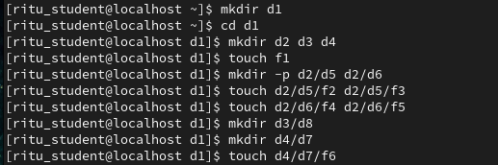
Output:
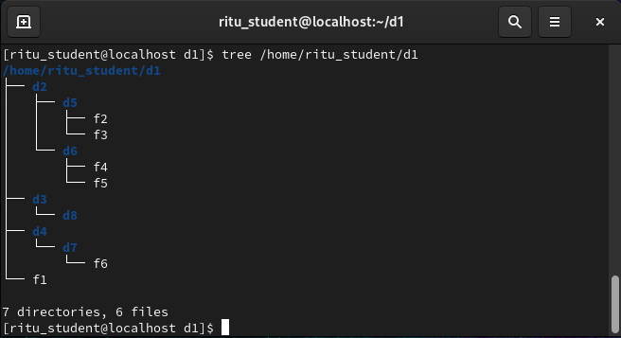

- Change permission of file f1 so that owner will get full permission, group member will get read & execute permission &others will only get read permission:
Command:
Output:
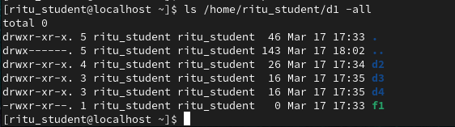

- Change permission of file f2 such that owner’s & group members will get read & write permission but others will get no permission:
Commands:
Output:
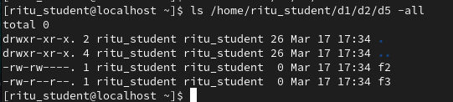

- Change permission & directory d3 such that all categories of works have full permission:
Command:
Output:
